**Serenity Visions: AI-Generated and Selected Patterns for Calming Video**

Xiang Yuheng Karina 3035947972

DESN3002

1. **Introduction**

One of many social norms in modern society is the prevalence of stress and anxiety issues that negatively impact mental health and wellbeing. While anxiety is common and sometimes necessary for motivation, an article from Harvard Medical School (2020), suggests that constant worrying and tension may detrimentally affect daily activities such as causing insomnia, thereby diminishing one’s quality of life. Although traditional methods of treating anxiety include medication, meditation, psychological therapy, and changing daily lifestyles, the effect of how design elements, particularly guided imagery in the form of geometric patterns, can improve mood and promote relaxation piques interest. For example, many phone applications often utilize symmetrical elements or other geometric elements associated with calming effects, suggesting that the visual design of patterns may have a strong influence on emotional states. One of these applications is the Apple Watch’s Breathe App, which guides users through mindfulness breathing exercises to achieve a stable breathing state with pattern scaling animations and vibrational feedback that brings calmness after completing the exercise.. To fully comprehend the psychological impacts of particular pattern characteristics that may contribute to relieving anxiety, further investigation is needed. The possibility of generating calming patterns through AI models is also an area worth researching.

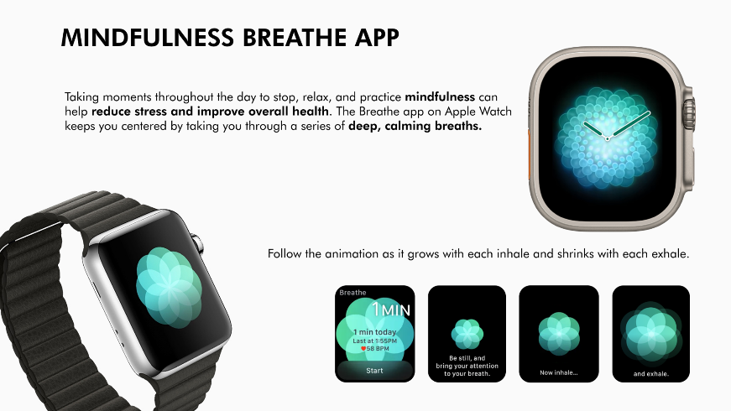

Figure 1: Feature description of the Mindfulness Breathing app on the Apple Watch.

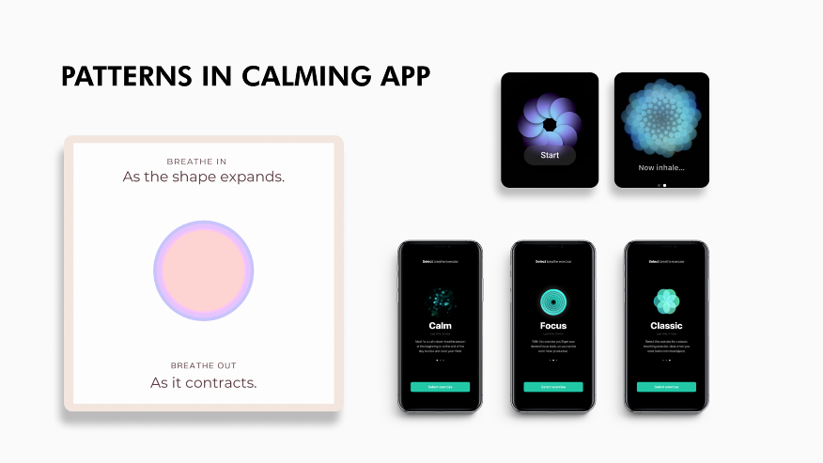

Figure 2: Patterns are also commonly used in other calming apps.

Prior research established five main characteristics of a geometric pattern that foster calmness, including symmetry, visual complexity, line composition, fractal patterns, and biophilic design. Many studies claim that symmetrical patterns, particularly those that emphasize more on reflective symmetry, rather than rotational or translational symmetry, are visually pleasing and can evoke positive emotions (Lindell & Mueller, 2011; Friedenberg, 2018; Pecchinenda et al., 2014). Moreover, as illustrated in the Gestalt Principle of Visual Perception (Interaction Design Foundation, 2024), these patterns should follow a continuous path and be composed of complete shapes to induce a calming effect. On the other hand, asymmetrical patterns that exhibit a certain level of irregularity and randomness promote excitement, which diverges from the aims of promoting calmness.

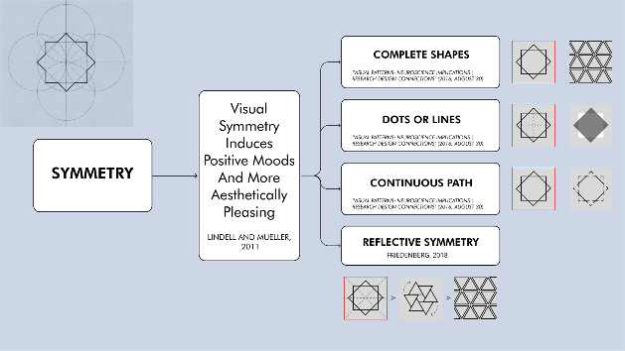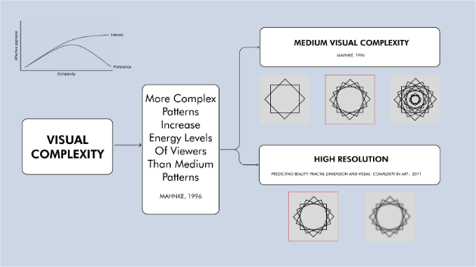

Figure 3: Example of patterns that demonstrate symmetry and medium visual complexity.

Visual complexity, which refers to the number, regularity, and organization of elements in a pattern, is also associated with arousal levels. Although visual complexity is positively correlated with the users’ energy levels (Mahnke, 1996), lower energy levels are required for relaxation, implying that moderate visual complexity should be achieved to promote calmness.

Furthermore, the composition of lines and shapes can convey different emotions and moods to the viewer. For example, horizontal and vertical lines are favored over diagonal lines because it is easier for the human brain to comprehend (Lindell & Mueller, 2011). Rounded shapes and curved lines also appear to elicit a pleasant and calming effect, whereas angular lines and V-shapes express negativity (Aronoff et al., 1992; Watson et al., 2012).

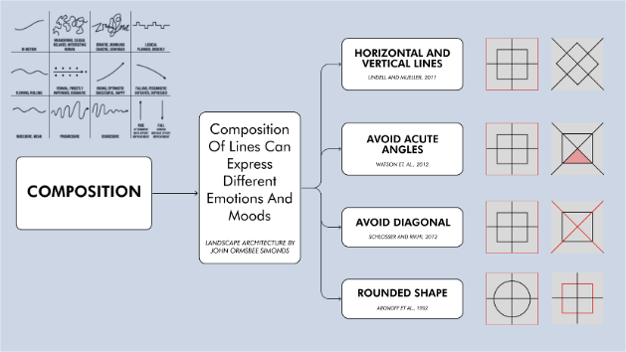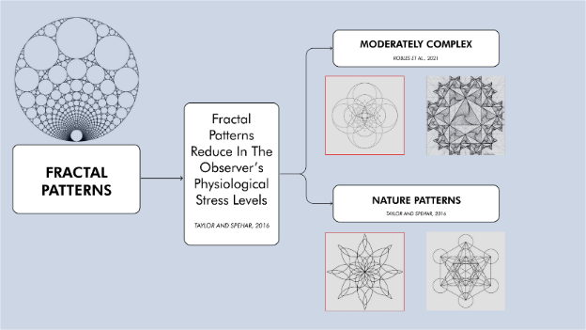

Figure 4: Examples of patterns that satisfy calming line composition and moderately complex fractal patterns.

Fractal patterns – complex patterns that exhibit repetitive patterns at different scales – are often accompanied by a reduction in physiological stress levels at moderate visual complexity. Studies suggest that the human visual system may prefer fractal patterns because they are inspired by elements found in natural environments, hence instilling a restorative effect (Abboushi et al., 2019).

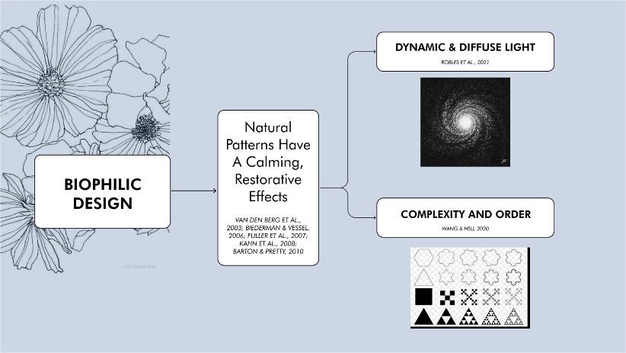

Figure 5: Examples of biophilic design, with reference to dynamic and diffuse light.

Finally, biophilic patterns, which refer to patterns that mirror natural patterns, such as honeycombs, wave ripples, snowflakes, and snail shells, are linked to stress reduction and improved wellbeing (Browning et al., 2014). The calming effects of biophilic patterns could also be enhanced by incorporating fractal patterns or a dynamic and diffuse light.

The key objective of this project is to create a calming, immersive pattern animation video through AI models by drawing on insights from a previous case study on the façade geometric patterns of the Al Bahr Tower and analyzing the emotional response to various geometric patterns. The project aims to provide a better understanding of how the design of visual elements can aid individuals in controlling their emotions. By exploring the opportunities in design-based therapy methods for improving mental health, individuals may be able to better cope with everyday anxiety.

The following sections will explain the methodology, implementation, results, and evaluation of the project. In Section 2, the scope of the project is introduced, along with the project’s overall process and workflow, as well as the key methods covered. In Section 3, the process of generating, evaluating, and improving patterns through iterative refinement, AI, and machine learning models will be discussed in detail. In Section 4, the findings of the project, including the effectiveness of the pattern generation method and the user feedback, is examined, while considering any limitations of the project. Finally, Section 5 summarizes the project’s findings and suggests potential future applications.

1. **Methodology** 
   1. **Scope**

This project examines the emotional impact of different geometric patterns by generating a pool of patterns using three AI models (Stable Diffusion XL, Midjourney, DALL -E 3). It is assumed that characteristics such as symmetry, continuity, medium visual complexity, curved / horizontal / vertical lines, fractal and biophilic patterns serve as design parameters for a calming pattern. Since colors is not considered in the design space, all patterns generated will be converted to monochrome (black and white). The calming effect of the generated patterns are then evaluated using an AI rating system via three models (ChatGPT3.5, ChatGPT4, Claude 3), which are assumed to be objective. Furthermore, the project applies the concept of latent space to create smooth transitions between chosen patterns in order to produce the final immersive video.

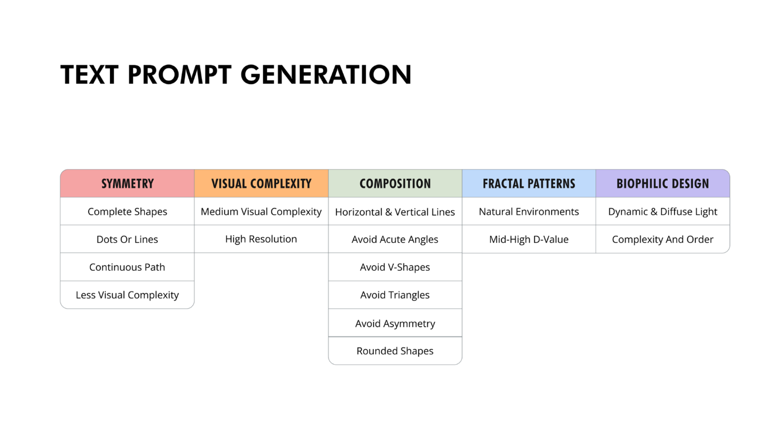This project is expected to create the most calming AI-generated pattern animation based on the aforementioned design parameters. The effectiveness of the patterns is verified through survey feedback, which investigates whether there are improvements in focus, calmness, and sleep induction. Aside from the design parameters, the design space also incorporates the use of generative AI models to create and evaluate patterns, as well as tools such as DynamiCrafter in ComfyUI to generate smooth pattern animations in the final video. The key design parameters are outlined below in Figure 6.

Figure 6: Five key characteristics of calming geometric patterns and associated keywords.

* 1. 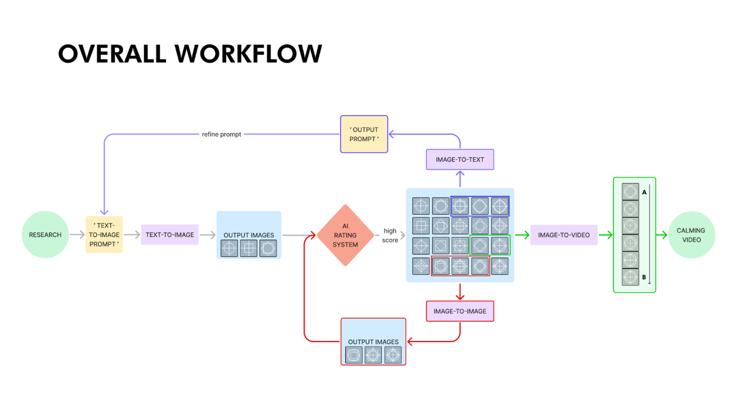**Overall Setup, Process, & Workflow**

Figure 7: Six-step workflow diagram to generate patterns and subsequent video.

This project’s workflow can be summarized into a 6-step process, as illustrated in Figure 7:

1. Research

Background research on the emotional effects (especially for calmness) of geometric pattern characteristics is first conducted to summarize five main characteristics that define a calming pattern, which is shown in Figure 6. The specified characteristics then serve as criteria for generating calming patterns, which allow text-to-image prompts to be developed.

1. AI Image Generation

The text-to-image prompts are inputted into the generative AI models (Stable Diffusion XL, Midjourney, DALL -E 3) to generate initial patterns. To determine the best-performing models, the outputs from the three models are compared according to the calming pattern criteria and image quality.

1. AI Chatbot Evaluation

An AI rating system by three AI chatbot models (GPT3.5, GPT4, Claude 3) is applied to objectively evaluate the generated patterns. The chatbots are instructed with a scoring prompt that requires them to rate the patterns out of 100 based on the calming pattern criteria. These AI models are tested to determine the most consistent and reliable models for further pattern evaluation. Finally, patterns that scored 90% and above are chosen and added to the pattern pool.

1. Iterative Refinement

The Midjourney image analysis tool is used to extract key features from the high-scoring patterns to further refine the generated patterns. These key features are combined with the original text prompt to refine the prompt. Subsequently, the refined prompt is inputted into the best performing models found in Step 2 and evaluated using the AI rating method in Step 3. The Midjourney image-to-image tool is also used to generate similar patterns. Patterns that scored 90% and above are then added to the pattern pool.

1. Creating Intermediate Frames and Transition Vedio

A pair of patterns from the final pattern pool were randomly selected and the development of intermediate frames was tested using methods like linear capacity transition, particle transformation, and DynamiCrafter (ComfyUI) machine learning to generate transition between two patterns.

1. Video Creation and User Feedback

A series of calming videos created by ComfyUI and background music is incorporated into the video through Adobe Preniere to enhance user experience. User feedback on the effectiveness of the video in improving focus, promoting calmness, and sleepiness is collected through a survey. The feedback is then analyzed to identify potential further improvements and applications.

* 1. **Key Methods & Concepts**

This section explains the key methods and concepts that appear in the overall workflow:

1. AI Rating System

The AI rating system is based off a scoring prompt comprising of six criteria (discussed in Section 3.2) that requires the AI chatbot to rate a specific pattern out of 100. The average of the six criteria ratings are then taken to determine the overall numerical score of the pattern.

1. Iterative Refinement Process

Midjourney’s image analysis and image-to-image tool aided in exploring the design space of high-scoring patterns and expanding the pattern pool. The image analysis tool analyzes visual components of an image and outputs a list of keywords that characterize the image’s features. These keywords help in refining the text prompts to generate new, high-scoring patterns. Similarly, the image-to-image tool creates variations of an input image while preserving the five calming pattern characteristics.

1. Latent Space

The latent space of pattern essentially refers to a hypothetical space that contains all possible calming patterns based on the established criteria. This guarantees that the generated transition frames between two patterns retain the calming properties throughout the animation sequence.

1. Linear Capacity Transition

Linear capacity transition is one of the methods experimented on to create intermediate frames for transitioning between two patterns. In this project, the transparency of two patterns were set to 50% and were overlapped to form the intermediate frame.

1. Particle Transformation

Particle transformation, an idea inspired by the concept of dynamic and diffuse light mentioned in the research, is another experimented method to create intermediate frames for transitioning. Touch Designer was used to convert the pattern image into small, white dots, thereby creating a more dynamic representation of the patterns.

1. DynamiCrafter Transitions

The final experimental method of creating transitioning frames between two patterns utilized a machine learning model called ‘DynamiCrafter’ – a plugin within the Comfy UI. Essentially, the model is trained on the final pattern pool and learns the characteristics or features that define a calming pattern. The model then produces intermediate frames that smoothly transition across the two given patterns while staying within the latent space of calming patterns.

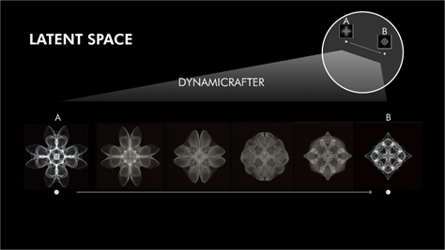

Figure 8: Demonstration of intermediate frames created by DynamiCrafter from pattern A to B.

1. Comfy UI Animation

In this project, the Comfy UI – a graphical user interface for the Stable Diffusion model – was used to create transitioning frames via the DynamiCrafter plugin and combining them to form a visually appealing animation.



Figure 9: Sample animated pattern based on patterns from the final image pool.

1. **Implementation**
   1. **Generating Designs**

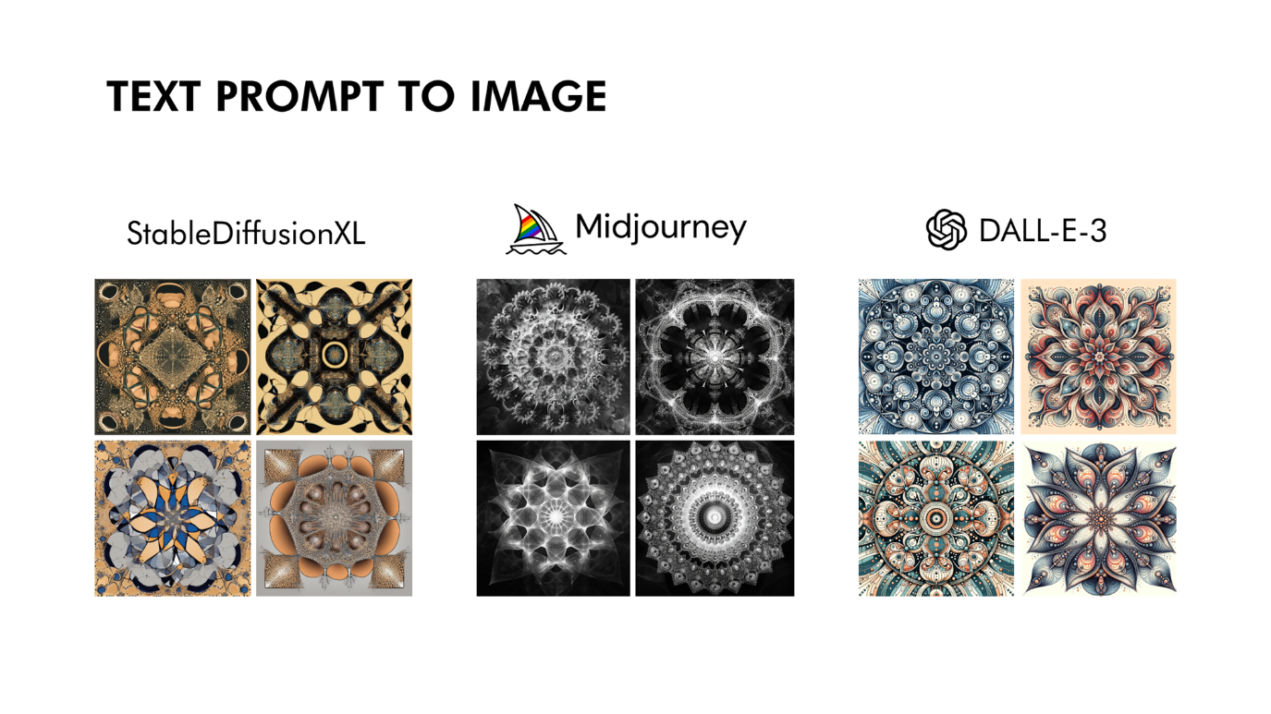The first step in generating calming geometric patterns was to create text-to-image prompts based on the five main characteristics outlined in Figure 6. These text prompts included phrases such as ‘Symmetry patterns with complete shapes’, ‘Dots and lines’, ‘Following continuous path with medium visual complexity’, ‘High resolution’, ‘Avoid acute angles and V-shape’, ‘Rounded shapes’, ‘Include fractal patterns and natural patterns’, and ‘Black and white’. These prompts were fed into Stable Diffusion XL, Midjourney, and DALL -E3 for initial pattern generation. The initial patterns are presented below in Figure 10.

Figure 10: Initial patterns generated by Stable Diffusion XL, Midjourney, and DALL -E3.

It can be observed from Figure 11 that some of the patterns generated by Stable Diffusion XL lacked sophistication, and some were even unable to align with the symmetry criteria. Hence, only Midjourney and DALL -E3 were kept for further pattern generation as they were able to correctly follow the specified criteria and exhibited high resolution.

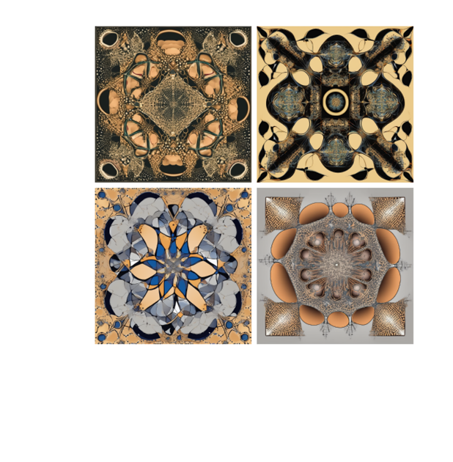

Figure 11: Stable Diffusion XL patterns lacking detail and symmetrical features.

* 1. **Evaluating Designs**

As mentioned in Section 2.2, an AI rating system was implemented by instructing ChatGPT3.5, GPT4, and Claude 3 to objectively assess the calming effect of the generated patterns as a ‘psychology scoring expert’. The scoring prompt considered the criteria for calming patterns, which is included below:

*“You are a pattern psychology scoring expert, and I will provide you with a pattern. The purpose of this pattern is to make the audience feel calm. Please rate the pattern on the following six criteria: 1. Rotational Symmetry; 2. Moderate Visual Complexity; 3. Avoidance of Downward V-Shapes; 4. Incorporation of Biophilic Designs; 5. Use of Curved or Rounded Shapes; 6. Reference to Fractal Patterns and Geometries for Stress Reduction. The scoring range is 0-100. Please rate based on my research and your judgment of the pattern’s calming effect.”*

Sample outputs from the three models were illustrated below in Figure 12:

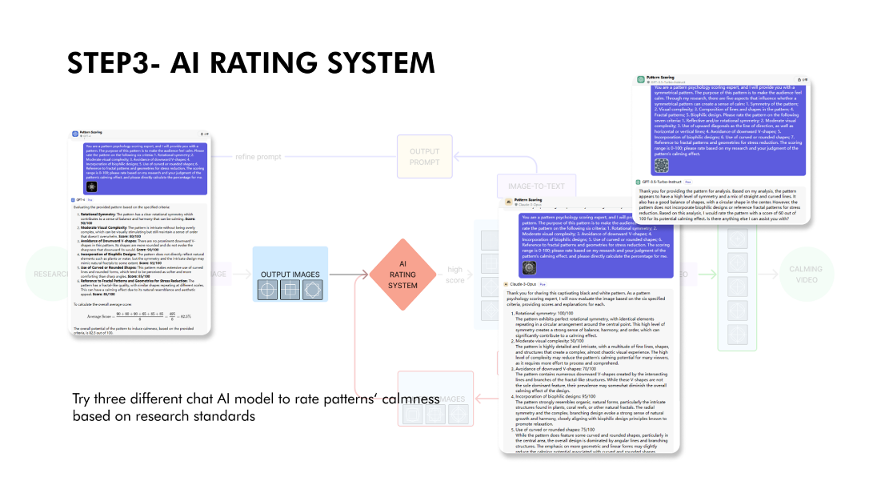

Figure 12: Sample rating outputs from GPT4 (left), GPT3.5 (middle), Claude 3 (right).

The average of the six ratings were calculated to determine a numerical score of the pattern’s calming effect. Initial patterns and patterns from research were fed into the three AI models as independent and control variables to test their ability to accurately assess the calming effect of the patterns.

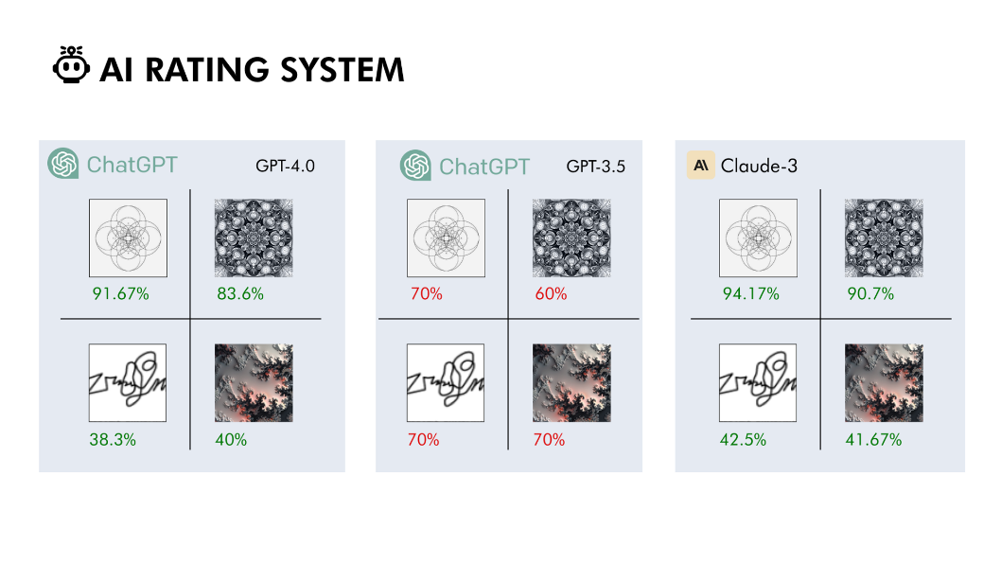

Figure 13: Patterns from Research (left column), AI Patterns (right column), calming (top row), chaotic (bottom row).

Based on Figure 13, it is observed that the GPT3.5 model was unable to accurately assess the calming effect based on the given criteria since it rated the chaotic pattern as 70% when the correct score should be approximately 40%. Hence, the GPT3.5 model was eliminated from the refinement and pattern evaluation process.

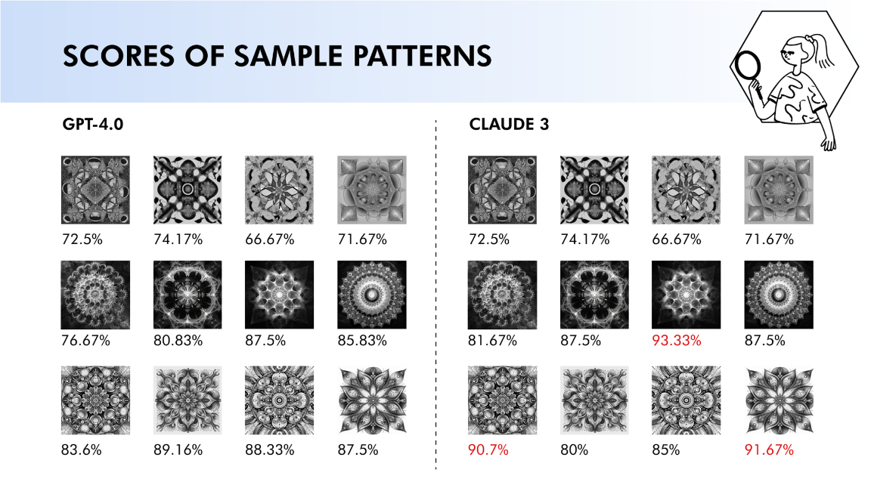The initially generated images were then converted to monochrome color and evaluated by GPT4 and Claude 3, and the patterns scoring 90% and above were added to the image pool (highlighted in red in Figure 14).

Figure 14: Ratings by GPT4 and Claude 3 on the initially generated patterns.

* 1. **ML Model Design**

The iterative refinement approach entailed developing refined prompts and subsequently generating new patterns to increase the pattern pool’s variety and calming effectiveness. As illustrated in Figure 15-16, keywords were generated from the Midjourney image analysis tool, and then merged with the initial text prompts to create new text prompts.

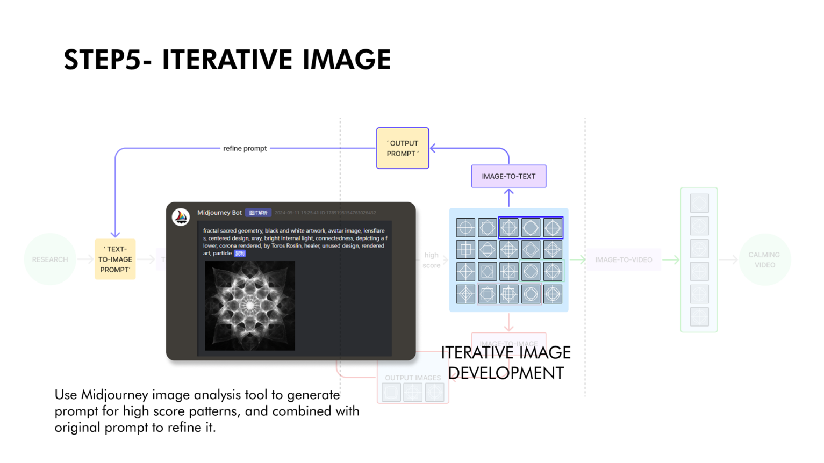

Figure 15: Illustration of the Midjourney image analysis tool in generating keywords.

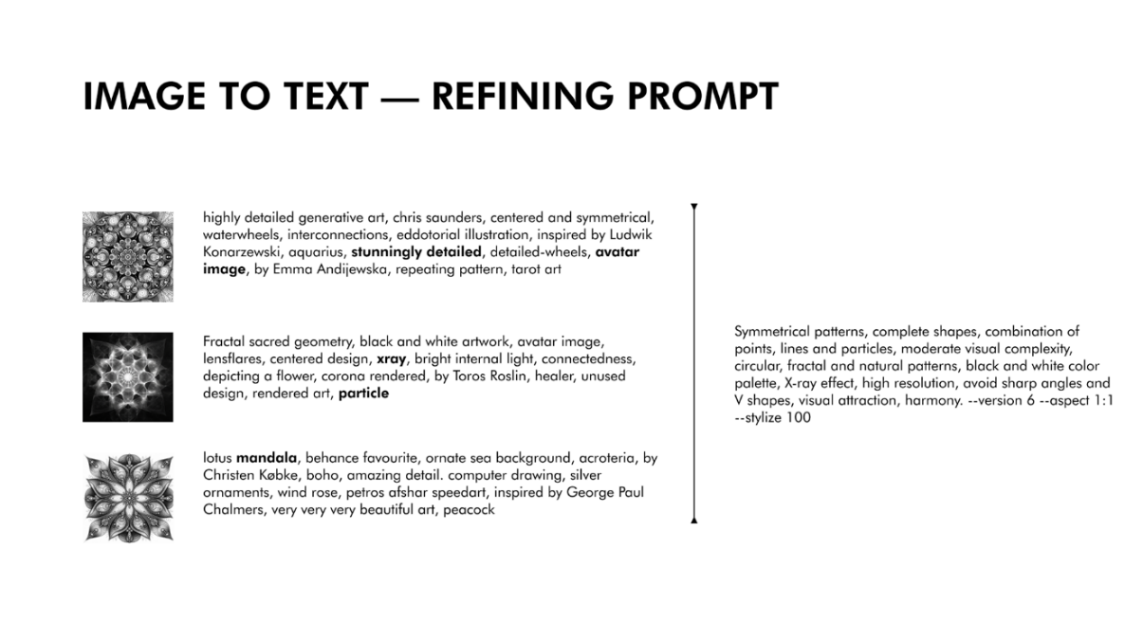

Figure 16: Extracting generated keywords from input image and combining them with original prompt.

The refined prompts were then inputted into Midjourney and DALL -E3 to generate new patterns that built on the foundations of the previous high-scoring patterns. Similarly, Midjourney’s image-to-image tool was utilized to generate new patterns to append to the image pool based on the 90% threshold.

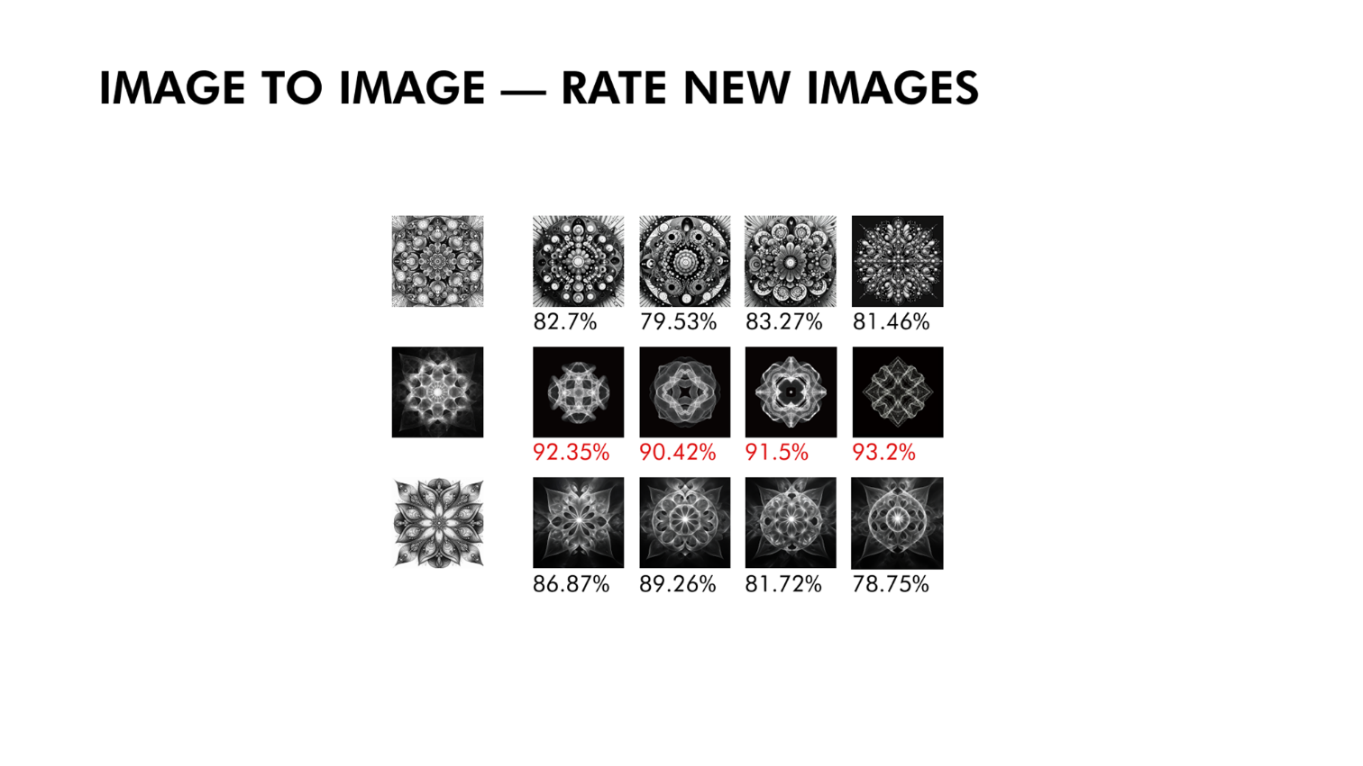

Figure 17: Illustration of using Midjourney image-to-image to generate new patterns.

In the final pattern animation video, three methods were employed to generate intermediate frames between two randomly selected patterns from the pattern pool. The first method used was ‘linear capacity transition’, which is reducing the transparency of both patterns to 50% and combining them to form the intermediate frame. However, the intermediate frame exhibited too much detail and appeared blurry, which failed to satisfy the visual complexity and high-resolution criteria, as illustrated in Figure 18.

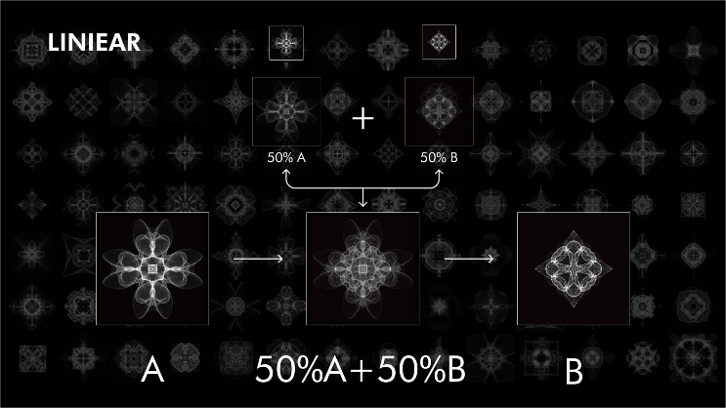

Figure 18: Attempt at using linear capacity transition; Intermediate frame clearly exhibits blurriness.

The second method involved transforming the patterns into white particles and automatically transitioning the particles from the starting pattern stage to the ending pattern stage in TouchDesigner. However, as the transitioning process was uncontrollable, it was difficult to verify whether the intermediate patterns formed remained within the latent space of a calming pattern. Moreover, the intermediate frame appeared blurry, as shown in Figure 19. This highlighted the need for a more complex approach to satisfy the calming criteria for patterns during transitions.

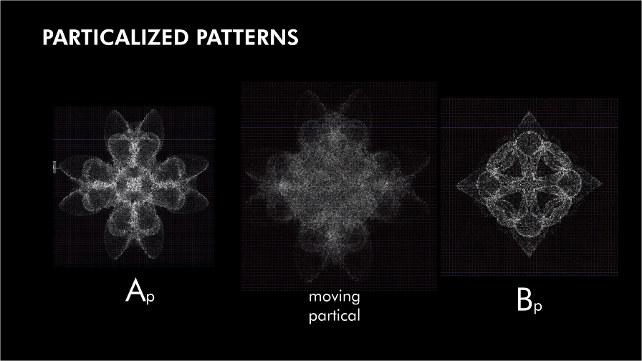

Figure 19: Attempt at using particle transformation; Intermediate frame has too much detail and blurriness.

The third method utilized DynamiCrafter, a plugin in the ComfyUI tool, where the model was trained on all patterns in the pattern pool. The model learnt similar characteristics between patterns to generate intermediate frames between two chosen patterns (Figure 8). The third method was the most appropriate for creating continuous patterns for the final pattern animation video because the machine learning process ensures that intermediate frames fall within the calming pattern criteria. Finally, all the frames are combined together to create transition video between each pair of patterns and edit them together with background music to enhance its immersive, calming experience.



Figure 20: Three sample animations exhibiting smooth transitioning between two given patterns.

1. **Results, Analysis, & Discussion**

Through the implementation of a logical, comprehensive workflow process, a varied pattern pool comprising of high-scoring, calming patterns was successfully created. Comparisons across the models during the initial pattern generation phase demonstrated that Midjourney and DALL -E3 consistently produced patterns that met the established criteria for calming patterns. AI ratings using GPT4, and Claude 3 observed to be an effective method in choosing high scoring patterns for further refinement. Additionally, these models were able to objectively evaluate the calming effect of patterns while fitting to human intuition. In the iterative refinement process, extracting key features from high-scoring patterns and combining them with original text-to-image prompts via Midjourney’s image analysis and image-to-image tools helped to generate new, enhanced variations. The calmness score of the new variations increased steadily, suggesting that the iterative process improved the overall quality of newly generated patterns. Furthermore, the survey feedback indicated that 77.5% of viewer felt more focused, 90% of viewers felt calmer, and 72.5% of viewers felt a sense of sleepiness after watching the pattern animation video. These results suggest that geometric patterns (visual stimuli) are a potentially effective method in promoting calmness and easing anxiety.

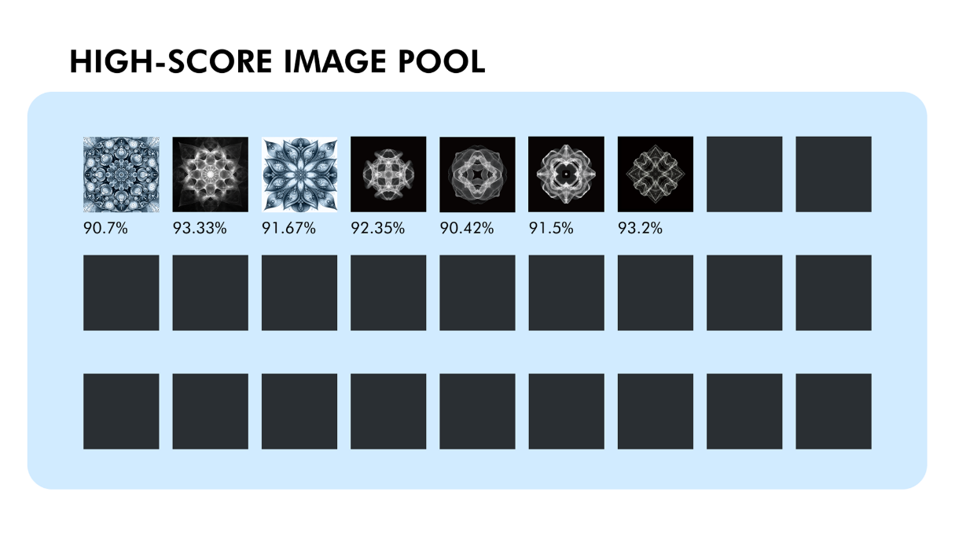

Figure 21: First three initial patterns (left); Next four iteratively refined patterns exhibit increased average rating.

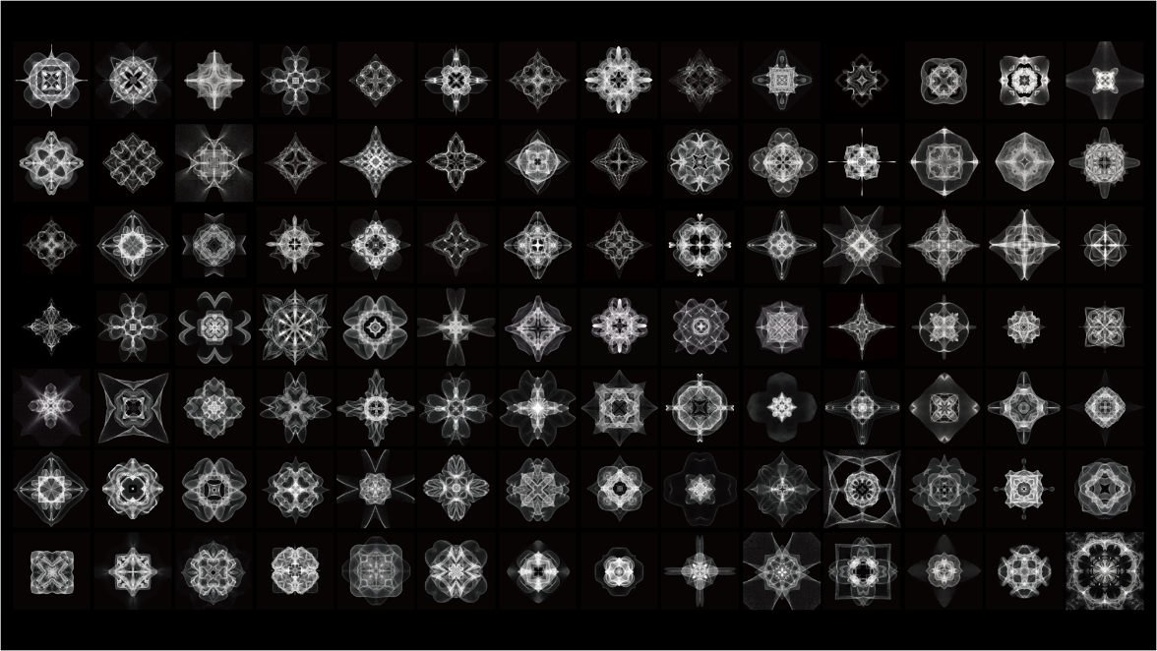

Figure 22: Patterns in the final image pool.

The workflow process’s results highlight how machine learning methods and AI models may be utilized to create aesthetically pleasing and calming geometric patterns. The generation of patterns that successfully integrated characteristics linked with calming effects demonstrate the capability of AI models to interpret and utilize text prompts. Moreover, employing various AI models to generate patterns and evaluate them showed that this was an appropriate approach. The consistency of Midjourney and DALL -E3 in generating high-quality patterns enabled a wide variety of pattern designs that surpass human imagination. Additionally, it reinforced their suitability in producing calming geometric patterns. Similarly, the reliability of GPT4 and Claude 3 suggested the potential of employing AI to objectively assess designs. Finally, smooth transitions in the final calming video enabled by ComfyUI demonstrate the capability of machine learning methods in producing emotionally captivating content. Overall, the application and results of using AI and machine learning to generate calming patterns illustrate their potential in reducing stress and managing anxiety.

However, the current limitations of this project are worth consideration. Since the AI rating system is assumed to objectively assess the pattern’s calming effect, it is important to validate this assessment on the generated patterns through human subject testing. Furthermore, physiological measurements such as heart rate and brain activity may help in confirming the rating system’s accuracy. Additionally, the project only focused on a limited number of visual characteristics to create a calming video. Hence, further research on the effects of other visual aspects like color, or elements like music and narration, on reducing anxiety, could aid in enhancing the overall immersive video experience.

1. **Conclusion**

In summary, this project’s design process, backed by AI models, illustrates a viable method for generating visually appealing and calming geometric patterns. A high-quality pattern pool was effectively constructed by integrating research-based criteria, various AI models for pattern generation and evaluation, and an iterative refinement process. This allowed a final calming video to be produced. The results of the project showed the successfulness of AI models in generating and evaluating patterns objectively based on specified criteria, as well as their potential in creating engaging visual experiences. The positive user feedback indicated improved focus, calmness, and sleepiness after watching the video, thereby corroborating the potential for geometric patterns in inducing calmness and alleviating anxiety.

To support the project’s conclusions, further validation by human subject testing and physiological monitoring is required due to its limitations. Furthermore, investigating whether other visual or auditory elements affect anxiety may aid in enhancing the visual experience of the video. Despite these limitations, the results suggest that calming patterns could be an effective visual stimulus for managing stress and anxiety in daily life. In the future, potential applications may include integrating the calming pattern animation in smart home appliances, such as when the Apple Watch detects the user is under stress, the system will notify the user to watch the calming video, creating a personalized relaxing experience.

**References**

Abboushi, B., Elzeyadi, I., Taylor, R., & Sereno, M. (2019). Fractals in architecture: The visual interest, preference, and mood response to projected fractal light patterns in interior spaces. *Journal of Environmental Psychology*, *61*, 57–70. https://doi.org/10.1016/j.jenvp.2018.12.005

Aronoff, J., Woike, B. A., & Hyman, L. M. (1992). Which are the stimuli in facial displays of anger and happiness? Configurational bases of emotion recognition. Journal of Personality and Social Psychology, 62(6), 1050–1066. [https://doi.org/10.1037/0022-3514.62.6.1050](https://psycnet.apa.org/doi/10.1037/0022-3514.62.6.1050)

Browning, W.D., Ryan, C.O., & Clancy, J.O. (2014). *14 Patterns of Biophilic Design*. New York: Terrapin Bright Green LLC. https://www.terrapinbrightgreen.com/reports/14-patterns/

Friedenberg, J. (2018). Perceived beauty of elongated symmetric shapes: Is more better? *Psychology of Aesthetics, Creativity, and the Arts*, *12*(2), 157–165. https://doi.org/10.1037/aca0000142

Harvard Medical School. (2020, April 27). Staying calm in turbulent times. *Harvard Health Publishing.* https://www.health.harvard.edu/mind-and-mood/staying-calm-in-turbulent-times

Interaction Design Foundation. (2024, May 8). *What are the Gestalt Principles?*. The Interaction Design Foundation. https://www.interaction-design.org/literature/topics/gestalt-principles

Lindell, A. K., & Mueller, J. (2011). Can science account for taste? Psychological insights into art appreciation. *Journal of Cognitive Psychology*, *23*(4), 453–475. https://doi.org/10.1080/20445911.2011.539556

Mahnke, F. H. (1996). *Color, environment, and human response: An interdisciplinary understanding of color and its use as a beneficial element in the design of the architectural environment*. Wiley.

Pecchinenda, A., Bertamini, M., Makin, A. D., & Ruta, N. (2014). The pleasantness of visual symmetry: Always, never or sometimes. *PLoS ONE*, *9*(3). https://doi.org/10.1371/journal.pone.0092685

Watson, D. G., Blagrove, E., Evans, C., & Moore, L. (2012). Negative triangles: Simple geometric shapes convey emotional valence. *Emotion*, *12*(1), 18–22. https://doi.org/10.1037/a0024495